**NOAA Ship THOMAS JEFFERSON Procedure Document**

Procedure:

**Primary Antenna Lever Arm Calibration**

Creation Date:

8/27/2020

Revision Date:

03/22/2022

Software used:

POSPac

Procedure Number:

**TBD**

Approved:

**TBD**

# Overview and Scope

How to conduct a lever arm calibration.

# Procedure Inputs and Outputs

## Inputs:

POS data (.000 files): Approximately 4 days’ worth for the ship and ½ day for the launches. The more motion from the vessel, the better, but data can be logged while alongside.

## Outputs:

# Procedure

1. Use the procedure for manual SBET processing to create a project in POSPac and import the POS data to be used for lever arm calibration. Follow all of the steps of the SOP but stop when you are about to run the GNSS-Inertial Processor and then follow the rest of this SOP.

2. Before you run the GNSS- Inertial Processor, go to Project Settings. Under the GNSS-Inertial Processor folder, select Lever Arms and Mounting Angles. Set the Standard Deviation to 10cm and click okay.

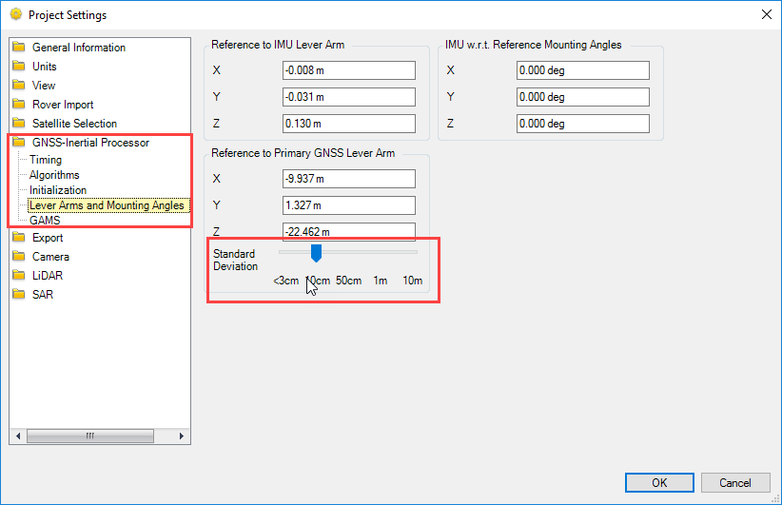

3. Run the GNSS-Inertial Processor for IN-Fusion PP-RTX.

4. When the GNSS-Inertial Processor is complete, select the reports tab at the top of the program and select display plots.

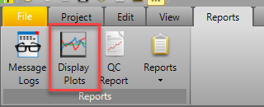

5. With the display plot window open, select the drop down for Calibrated Installation Parameters. See if your Reference-Primary GNSS Lever Arm Figure of Merit is at 100. If the Figure of Merit did not reach 100, you will need to collect more POS data and try again. The POS data record needs to be continuous, so if logging was ended, re-start logging and collect for a longer period of time. If you are doing this for the ship it will take about 4 days’ worth of POS to reach a figure of merit of 100.

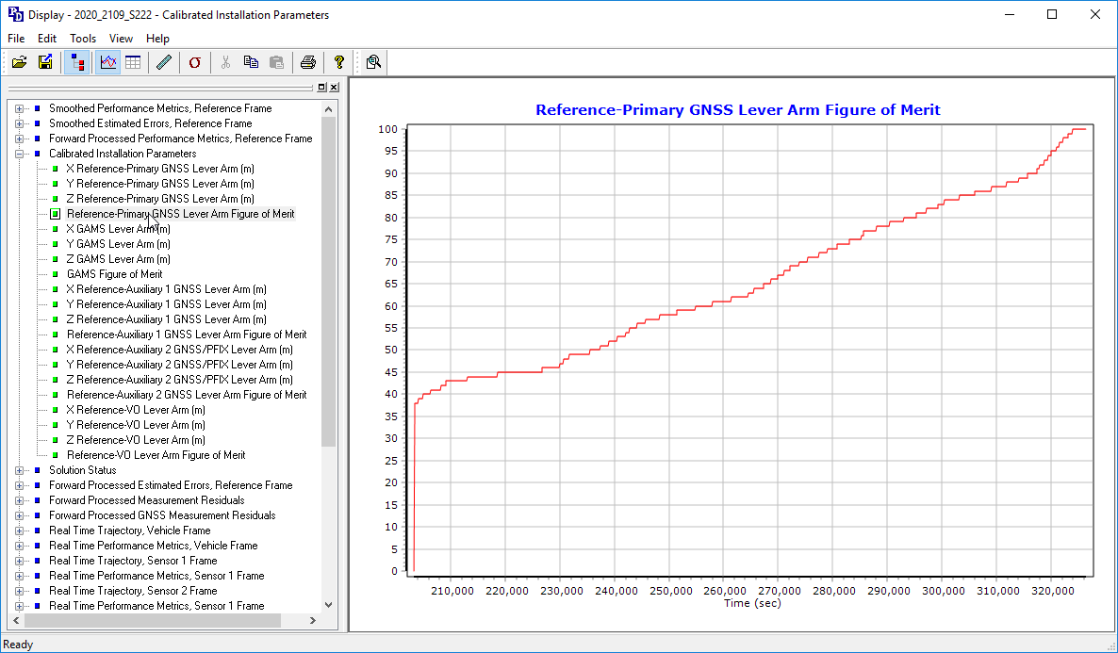

6. If the Figure of Merit does reach 100, select the X Reference-Primary GNSS Lever Arm and zoom in on the last section of the chart on the right. This ending value is the calibrated value for X. Write down the values for X, Y, and Z.

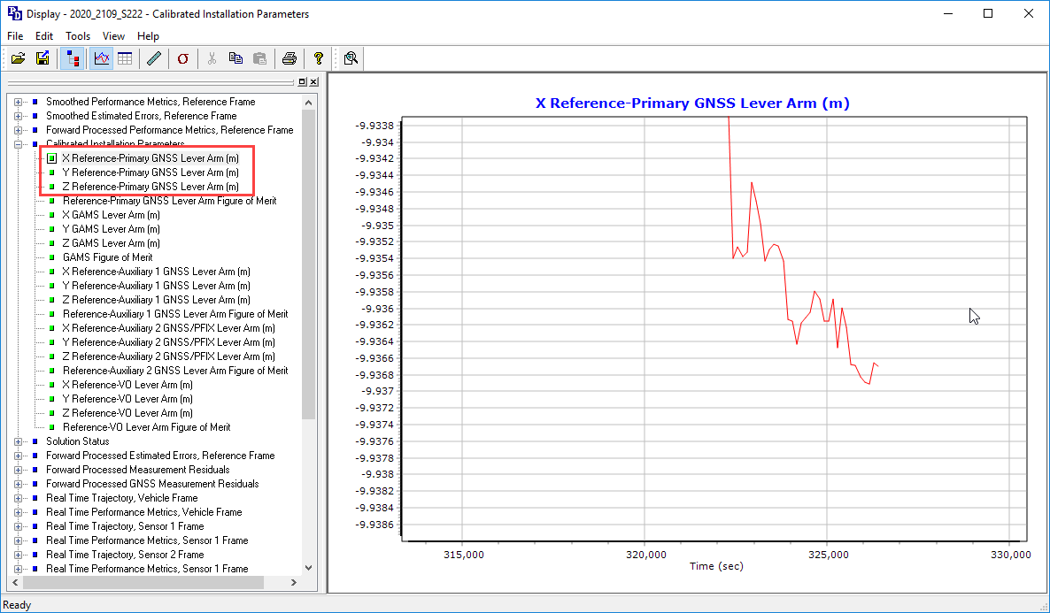

7. After you have your values for X, Y, and Z, go back to the Project Settings and enter these values into the Reference to Primary GNSS Lever Arm for each respective lever arm.

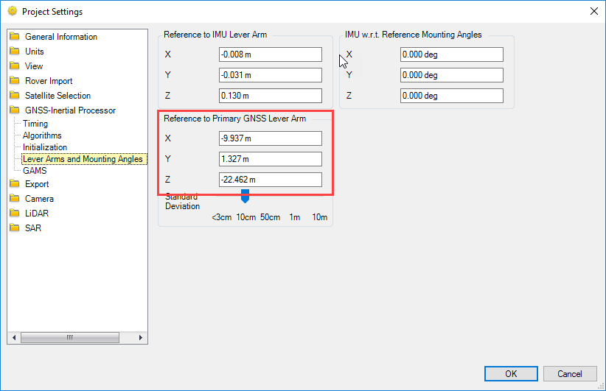

8. Now rerun GNSS-Inertial Processor.

9. Repeat steps 6-8 until the starting lever arm is close to the ending calibrated value.

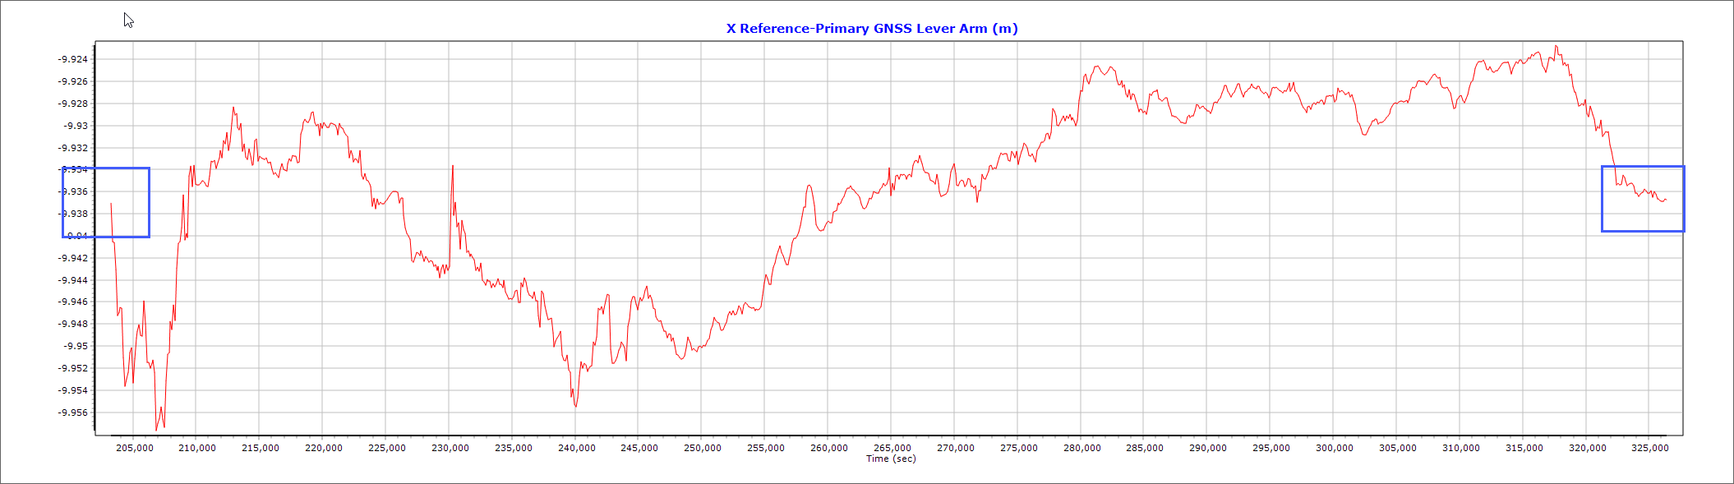

10. After finding your final calibrated values, input these values into POSView in “Settings” > “Installation” > “Lever Arms & Mounting Angles” within the Ref. to Primary GNSS Lever Arm section (See image below).

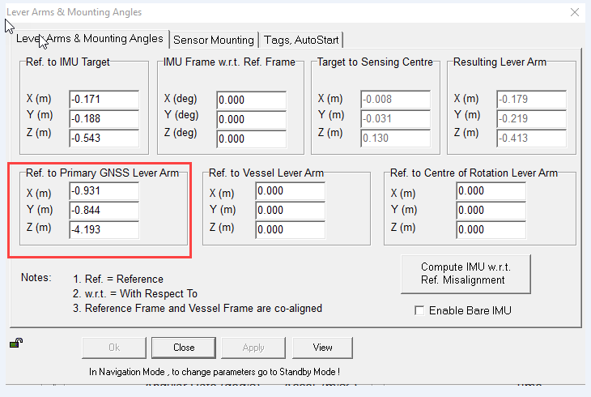

11. With your values now entered into POS, Click the monitor button in order to disconnect from the system and save the values. If you do not save, your values will revert when the system is restarted.

